HandsMen Thread: Elevating the Art of Sophistication in Men’s Fashion

Project Overview
The HandsMen Thread Salesforce app is a Customer Relationship Management (CRM) tool designed to enhance the functions of a men’s fashion enterprise. This CRM platform assists with activities such, as handling customer data monitoring product stock managing order fulfillment overseeing marketing campaigns and dispatching automated email alerts.
By using Salesforce objects, automation tools, Apex classes, and custom UI elements, this application creates a smooth workflow from customer creation to order confirmation. It also keeps inventory levels accurate and sends necessary alerts.

Objectives:
The primary objective of the HandsMen Thread Salesforce application developed through a CRM system is to enhance and simplify the essential functions of a men’s fashion business. This project intends to boost efficiency by automating tasks such as order handling, customer administration, inventory monitoring and email alerts. Additionally it strives to unify all customer, product and order information, within one platform to ensure accuracy and provide real-time insights

Phase 1: Requirement Analysis and Planning
- Understanding Business Requirements: Summarize the user needs and problems being solve
  - The main operational issues in running a men's fashion company were intended to be addressed by the HandsMen Thread application. Users required a centralized system that would support marketing initiatives, automate inventory tracking, expedite order processing, and simplify customer management. Tracking stock availability, verifying customer information, calculating order totals, and sending timely notifications were all challenging due to the manual processes that were in place. The project seeks to address the issues of inconsistent data, delayed order updates, poor inventory visibility, and an unorganized promotional structure by comprehending these needs. All things considered, the system offers a more effective, precise, and automated method of handling clients, goods, orders, and marketing initiatives.

- Defining Project Scope and Objectives
  - This project will result in the design and build of a unique Salesforce-based management application specifically for managing a men’s Fashion business. Features include:

    - Creation of custom object and field structures to manage customer, order, product, and inventory information.
    - Use of Salesforce Flows to automate the processes to process orders; notify users of low-stock and send email alerts.
    - Programming of Apex code to perform calculations as well as logic that cannot be created using declarative tools.
    - Custom user-interface/user-experience features such as Lightning page creation, Lightning-based page layouts and App Launcher customization.
    - Enablement of marketing functions using: campaigns; reports and dashboards based on Salesforce data.
    - Configuration of Security features (Field-Level Security, Profile Permissions & User Access Control).
    - Integration of all of the above processes it includes customer creation, order confirmation and inventory update processing.
    - The project will result in the delivery of a simple, accurate and scalable Salesforce-based CRM that increases the efficiency of the men's fashion enterprise and supports its long-term objectives.
- Designing the Data Model and Security Model
  - Data Model Design
    - The data model was created to represent the business processes efficiently. Key decisions included:
      - Establishing four primary custom objects HandsMen Customer, HandsMen Product, HandsMen Order, and Inventory.
      - Creating lookup and master-detail relationships to link orders with customers and products.
      - Adding calculated fields for total amount, stock levels, and order quantities.
      - Ensuring the model supports automation for inventory updates and order workflows.
  - Security Model
    - A robust security model was implemented to protect sensitive business and customer data.
      - Defined profiles and permission sets to control access to custom objects.
      - Applied field-level security for confidential information such as customer emails.
      - Established role hierarchy to ensure proper data visibility.
      - Implemented validation rules to ensure only accurate and complete data is entered.
      - Ensured that automation and Apex logic comply with Salesforce governor limits and best practices.
- Stakeholder Mapping and Execution Roadmap
  - Stakeholder Mapping
    - Project Owner / Business Manager – Defines requirements and approves major system functionalities.
    - Salesforce Administrator – Configures objects, fields, security settings, and automation tools.
    - Salesforce Developer – Handles Apex classes, triggers, and advanced customizations.
    - End Users (Sales Staff / Inventory Staff) – Use the system to manage customers, orders, and products.
    - QA / Tester – Performs testing to ensure the system meets quality and accuracy standards.
  - Execution Roadmap
    - The project adhered to a defined and simple plan. I started by grasping the requirements and determining the users needs. Next I designed the data model and security framework to guarantee the system was structured and protected. Following that I created the backend operations and automation then tailored the user interface to enhance usability. After completing the build I tested the functionalities to verify they functioned properly. Finally, I deployed the project and prepared it for regular use, with plans for ongoing updates and maintenance.

Phase 2: Salesforce Development – Backend & Configurations
- Setup Environment & DevOps Workflow
  - For this project, I prepared the Salesforce environment by creating a dedicated HandsMen Thread Lightning App. I configured the app launcher for easy navigation and arranged the custom objects needed for the business process. A structured DevOps workflow was followed by developing the customizations inside a safe sandbox environment. Once all configurations and tests were completed, the final components were deployed into production using change sets. This ensured that the development was organized, controlled, and aligned with Salesforce best practices.
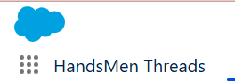

- Customization of Objects, Fields, Validation Rules, and Automation
  - I created the main objects required to support the men’s fashion business workflow including HandsMen Customer to store customer profiles. HandsMen Order that records customer orders, status, quantity, and total amount. HandsMen Product that contains product details like SKU, price, and stock quantity. And Inventory to tracks available stock per warehouse or storage location.

- Validation Rules
  - Validation rules were created to ensure data accuracy and completeness, such as, requiring an email address for customer creation. Ensuring SKU values are unique for each product. Preventing order creation if the quantity exceeds available inventory.
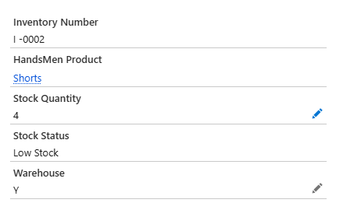
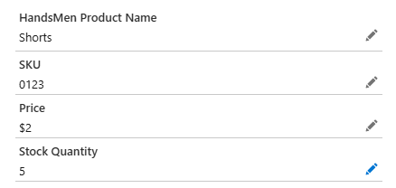

- Automation Tools Used (Flows)
  - To automate processes, I used Salesforce Flows such as, Order Confirmation Flow, Inventory Update Flow, and Low Stock Alert Flow.

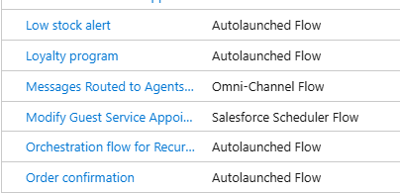

  - Apex Classes, Triggers, and Asynchronous Apex (If Developed)
    - For the Apex development, I created a class that automatically calculates the total number of orders, total quantities, and total amount based on the records in the system. I also added a basic Apex trigger to update these values whenever a new order is created or modified. These Apex components work alongside the flows to ensure accurate and real-time data processing throughout the HandsMen Thread application.

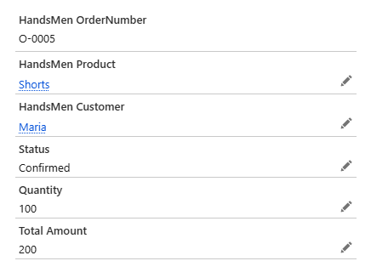

Phase 3:UI/UX Development & Customization
- For this phase, I focused on creating an intuitive and user-friendly interface for the HandsMen Thread app. I set up the app using Lightning App Manager to organize navigation and make it easy for users to access the main objects: Customers, Orders, Products, Inventory, and Marketing Campaigns.
I customized page layouts and dynamic forms to display relevant information clearly and allow quick actions such as creating new customers, orders, or products. User management was configured to assign roles, profiles, and permissions so that each user only sees the data they need.
I also developed reports and dashboards to provide insights into sales, orders, and inventory status, giving users a visual way to monitor business performance. For enhanced interactivity, Lightning Pages were designed to organize data and actions on a single view. All UI/UX developments were demonstrated to ensure smooth navigation, clear visibility of information, and an overall pleasant user experience.
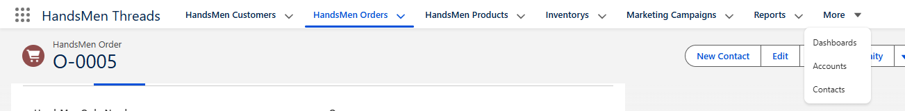

Phase 4: Data Migration, Testing & Security
- Data Migration
  - I used Data Import Wizard to load sample customer, product, order, and inventory data into Salesforce. This allowed the system to be tested with real-like records while maintaining data accuracy.
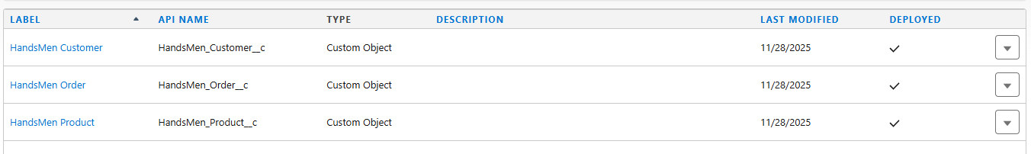
- Field Tracking & Duplicate Management
  - Field history tracking was enabled on key objects such as Orders and Inventory to monitor changes. Duplicate rules and matching rules were set up to prevent duplicate customer or product entries.

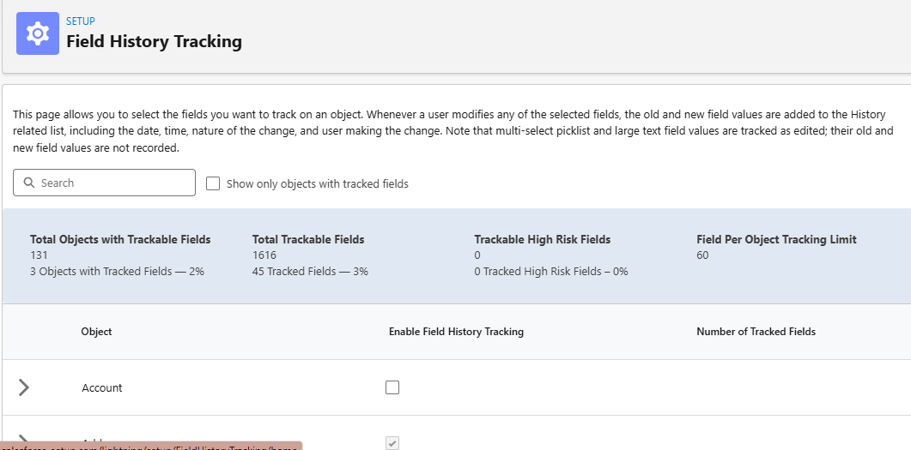

- Security Configuration
  - I configured profiles, roles, and role hierarchy to control access. Permission sets and sharing rules were applied to ensure that sensitive data, like customer emails and order details, were only accessible to authorized users.

Phase 5: Deployment, Documentation & Maintenance
- In this phase, the HandsMen Thread application was deployed from the sandbox environment to production using change sets, ensuring that all custom objects, fields, flows, Apex classes, and page layouts were transferred safely and accurately.
- For maintenance and monitoring, the system will be regularly checked to ensure smooth operation. This includes monitoring inventory levels, verifying order processing, reviewing email automation, and updating product or customer data as needed. Any updates to flows, Apex classes, or security settings will be documented and applied carefully to avoid disruption.
- A troubleshooting approach was also prepared, which includes identifying errors through debug logs, reviewing flow and trigger executions, checking user permissions, and using test cases to verify correct functionality. This documentation ensures that future issues can be resolved efficiently and the system remains reliable.
Conclusion
The HandsMen Thread application successfully delivers a comprehensive Salesforce solution for managing customers, products, orders, inventory, and marketing campaigns in a men’s fashion business. Through careful planning, backend development, UI/UX customization, data migration, testing, and secure deployment, the system automates key business processes and provides accurate, real-time information. The combination of flows, Apex classes, and customizable reports ensures efficiency, data integrity, and improved decision-making. With proper maintenance and monitoring, the HandsMen Thread application is a scalable and reliable platform that supports the growth and operational needs of the business while enhancing user experience and overall productivity.

